Assignment – 5
Text identification using OpenCV, Tesseract
(OCR) and deep neural network

Problem Statement:
The goal of this assignment is to implement text identification in images using OpenCV, Tesseract OCR, and a Deep Neural Network (DNN). Optical Character Recognition (OCR) refers to the process of detecting and extracting text from images or scanned documents. The objective is to create a system that can identify and extract text from input images, which can be useful for applications like document digitization, license plate recognition, and form processing.

Software used:
- Python 3.x
- Google Colab

Libraries and packages used:
- opencv-python: For image loading, preprocessing, and manipulation.
- pytesseract: Tesseract OCR library to extract text from images.
- tensorflow / keras (Optional): If custom DNN is used for text detection.
- numpy: For numerical operations.
- matplotlib: For visualizing images and results.

Theory:
Optical Character Recognition (OCR) is the process of converting images of text (handwritten, typed, or printed) into machine-encoded text. The process involves detecting text regions, recognizing the characters, and converting them into digital text.
- OpenCV: Used for preprocessing images (resizing, thresholding, contour detection) to enhance text regions.
- Tesseract: An open-source OCR engine that recognizes characters from pre-processed images.
- Deep Neural Networks (DNNs): Can be used for custom text detection models, especially for identifying regions of text in complex images before applying OCR.

Methodology:
- Data Collection: Collect images containing text, such as scanned documents, street signs, or license plates.
- Image Preprocessing: Use OpenCV to preprocess the images by resizing, thresholding, and enhancing text regions.
- Text Detection: Use OpenCV to detect text regions in the image using contours or bounding boxes.
- Text Recognition:
  - Apply Tesseract OCR to recognize and extract text from the detected regions.
  - Optionally, use a DNN model to improve text detection accuracy in complex images.
- Post-processing: Clean the extracted text (removing noise, correcting misrecognized words) and output the results.

Advantages:
- Automated Text Extraction: Quickly extracts text from images, eliminating the need for manual transcription.
- Versatile: Can be used on different types of text images, including scanned documents, street signs, and even handwritten notes.
- Open-source Tools: Tesseract OCR and OpenCV are free and widely supported.

Limitations:
- Accuracy Dependence on Image Quality: OCR performance can degrade if the image is low resolution or contains noise.
- Limited for Handwritten Text: Standard Tesseract OCR performs well on printed text but struggles with handwriting.
- Language Limitations: Tesseract needs specific language training data to recognize non-English characters effectively.

Applications with example:
- Document Digitization: Scanning and converting printed documents into editable text.
- License Plate Recognition: Automatically recognizing and extracting license plate numbers from vehicle images.
- Form Processing: Extracting text fields from scanned forms, receipts, and invoices.
Example: Recognizing text from a scanned receipt to extract item names, prices, and totals.

Working / Algorithm:
- Image Preprocessing:
- Load the image and convert it to grayscale.
- Apply thresholding or edge detection to highlight the text regions.
- Text Detection: Use OpenCV to detect contours or bounding boxes around text regions.
- Text Recognition (Using Tesseract): Pass the detected regions to Tesseract for OCR.
- Post-processing: Clean the OCR output by removing noise and correcting errors.

Diagram:

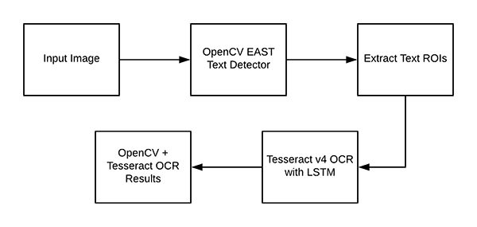

Conclusion:
In this assignment, we implemented text identification using OpenCV for image preprocessing, Tesseract OCR for text recognition, and optionally a Deep Neural Network for improved text detection. The solution demonstrates how to preprocess images, detect text regions, and extract the text using Tesseract. This approach is applicable to various real-world problems, including document digitization, license plate recognition, and form processing. The integration of OpenCV and Tesseract provides an effective solution for text extraction from images.

